Preparation of Papers for TiFEC - 2025

*Author* Name Surname1, (Supervisor N. Surname1)

*1Full name of the Institution, Faculty,*

*contact.author@mailserver.com*

# Introduction

If the supervisor is not mentioned above, it is recommended to express gratitude in Acknowledgment section. The size of the paper is A4. The paper should be prepared using Microsoft Word (*.doc, *.docx) and submitted using our on-line manuscript submission system. The recommended size of the paper is no more than 6 pages.

# Section name

This document is a template for Microsoft Word. Text formatting is done using markup styles (at the left of the Formatting Toolbar at the top of your Word window). The list of markup styles used:

* KTU:Table title
* KTU:Authors
* KTU:References
* KTU:Equation
* KTU: fig. caption
* KTU:Text
* KTU:Heading 1
* KTU:Heading 2
* KTU:Apendix
* KTU:Title
* Table Content
* Table Header
* KTU:Abstract

Use italics for emphasis; do not underline. Do not change the font sizes or line spacing to squeeze more text into a limited number of pages. If necessary, use nonbreaking space Ctr+Shift+Space. When editing use Ctrl+* to see hidden formatting.

# Tables, Figures

Figure captions are written under the figures (Fig. 1), table captions over the tables (Table 1). Numbering is in Arabic numerals. All tables and figures must be mentioned in the text. Please verify that the figures and tables you mention in the text actually exist.

# Equations

The equations should be prepared using “Microsoft Equation 3.0” or “MathType” editor, and appear in a text as a separate object. (Insert | Object | Create New | Microsoft Equation 3.0 or MathType Equation). “Float over text” should not be selected. The equations may also be prepared using built-in “Microsoft Equation” editor.

Equations should be numbered consecutively with Arabic numerals and aligned right as in (1). First use the equation editor to create the equation. Then select the markup style *KTU:Equation*. Punctuate equations when they are part of a sentence, as in

 (1)

Be sure that the symbols in your equation have been defined before the equation appears or immediately following. Italicize symbols (*T* might refer to temperature, but T is the unit tesla). Refer to “(1),” not “Eq. (1)” or “equation (1),” except at the beginning of a sentence: “Equation (1) is ...”.

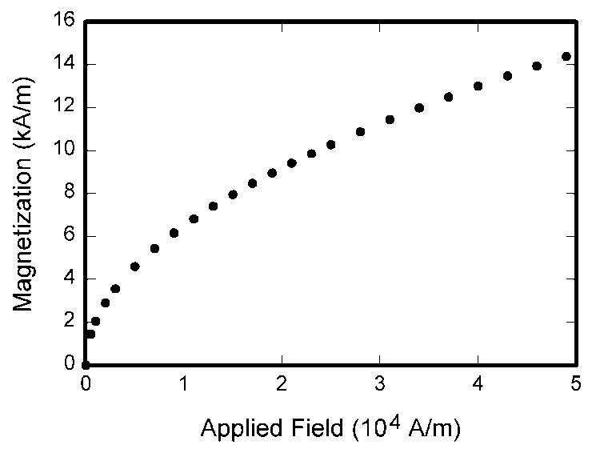

Fig. 1. Magnetization as a function of applied field. Note that “Fig.” is abbreviated. There is a period after the figure number, followed by two spaces. It is good practice to explain the significance of the figure in the caption.

Table 1. Recommended fonts.

|  |  |  |  |
| --- | --- | --- | --- |
| Item | Font | Size | Style |
| Title of paper | Times New Roman | 24 pt | Normal |
| Authors' names | Times New Roman | 11 pt | Normal |
| Authors' address | Times New Roman | 11 pt | Italic |
| Abstract | Times New Roman | 9 pt | Bold |
| Title of sections | Times New Roman | 10 pt | Normal |
| Text, Formulae | Times New Roman | 10 pt | Normal |
| Algorithms | Courier New | 10 pt | Normal |

# Helpful Hints

## Abbreviations and Acronyms

Define abbreviations and acronyms the first time they are used in the text, even after they have already been defined in the abstract. Abbreviations such as SI, ac, and dc do not have to be defined. Do not use abbreviations in the title unless they are unavoidable.

## References

Number the citations consecutively, in square brackets [1]. The sentence punctuation follows the brackets [2]. Multiple references [2], [3] are each numbered with separate brackets [1]–[3].

# Conclusions

Conclusions may review the main points of the paper, do not replicate the abstract as the conclusion. Conclusions might elaborate on the importance of the work or suggest applications and extensions. Make sure that the whole text of your paper observes the textual arrangement on this page.

Appendix A

Appendices, if present, must be marked A, B, C and placed before the Acknowledgment section.

Acknowledgment

Place your acknowledgments before References.

References

1. W.-K. Chen, *Linear Networks and Systems* (Book style). Belmont, CA: Wadsworth, 1993, pp. 123–135.
2. H. Poor, *An Introduction to Signal Detection and Estimation*. New York: Springer-Verlag, 1985, ch. 4.
3. B. Smith, “An approach to graphs of linear forms (Unpublished work style)”, unpublished.
4. E. H. Miller, “A note on reflector arrays (Periodical style—Accepted for publication)”, *IEEE Trans. Antennas Propagat*., to be published.
5. J. Wang, “Fundamentals of erbium-doped fiber amplifiers arrays (Periodical style—Submitted for publication)”, *IEEE J. Quantum Electron*., submitted for publication.
6. M. Young, *The Techincal Writers Handbook*. Mill Valley, CA: University Science, 1989.
7. J. U. Duncombe, “Infrared navigation—Part I: An assessment of feasibility (Periodical style)”, *IEEE Trans. Electron Devices*, vol. ED-11, pp. 34–39, Jan. 1959. [Online]. Available: http://dx.doi.org/10.4316/ieee.1959.3422
8. S. Chen, B. Mulgrew, and P. M. Grant, “A clustering technique for digital communications channel equalization using radial basis function networks”, *IEEE Trans. Neural Networks*, vol. 4, pp. 570–578, Jul. 1993.
9. R. W. Lucky, “Automatic equalization for digital communication”, Bell Syst. Tech. J., vol. 44, no. 4, pp. 547–588, Apr. 1965.
10. S. P. Bingulac, “On the compatibility of adaptive controllers (Published Conference Proceedings style)”, in *Proc. 4th Annu. Allerton Conf. Circuits and Systems Theory*, New York, 1994, pp. 8–16.
11. G. R. Faulhaber, “Design of service systems with priority reservation”, *in Conf. Rec. 1995 IEEE Int. Conf. Communications*, pp. 3–8.
12. W. D. Doyle, “Magnetization reversal in films with biaxial anisotropy”, in 1987 *Proc. INTERMAG Conf*., pp. 2.2-1–2.2-6.
13. G. W. Juette and L. E. Zeffanella, “Radio noise currents n short sections on bundle conductors (Presented Conference Paper style)”, presented at the IEEE Summer power Meeting, Dallas, TX, Jun. 22–27, 1990, Paper 90 SM 690-0 PWRS.
14. J. Williams, “Narrow-band analyzer (Thesis or Dissertation style)”, Ph.D. dissertation, Dept. Elect. Eng., Harvard Univ., Cambridge, MA, 1993.
15. N. Kawasaki, “Parametric study of thermal and chemical nonequilibrium nozzle flow”, M.S. thesis, Dept. Electron. Eng., Osaka Univ., Osaka, Japan, 1993.
16. J. P. Wilkinson, “Nonlinear resonant circuit devices (Patent style)”, U.S. Patent 3 624 12, July 16, 1990.
17. *IEEE Criteria for Class IE Electric Systems* (Standards style), IEEE Standard 308, 1969.
18. *Letter Symbols for Quantities*, ANSI Standard Y10.5-1968.
19. R. E. Haskell and C. T. Case, “Transient signal propagation in lossless isotropic plasmas (Report style)”, USAF Cambridge Res. Lab., Cambridge, MA Rep. ARCRL-66-234 (II), 1994, vol. 2.
20. E. E. Reber, R. L. Michell, and C. J. Carter, “Oxygen absorption in the Earth’s atmosphere”, Aerospace Corp., Los Angeles, CA, Tech. Rep. TR-0200 (420-46)-3, Nov. 1988.
21. (Handbook style) *Transmission Systems for Communications*, 3rd ed., Western Electric Co., Winston-Salem, NC, 1985, pp. 44–60.
22. *Motorola Semiconductor Data Manual*, Motorola Semiconductor Products Inc., Phoenix, AZ, 1989.

Abstract

Name Surname. Name of the paper. The abstract of the paper. The style of the abstract text – *KTU:Abstract*.